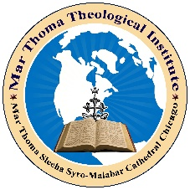

Mar Thoma Theological Institute
(St. Thomas Syro Malabar Diocese of Chicago)
Introducing
Diploma Courses in Biblical Studies
In affiliation with
Paurastya Vidyapitham
Pontifical Oriental Institute of Religious Studies

The next one-year diploma course
“Diploma in Gospel Studies”
starting
on
May 15, 2022
    - Classes are conducted on the WebEx platform every other Sunday at 8:00 pm Central Standard Time
- The Bible Scholars of Pontifical Oriental Institute impart classes
- The participants can attend the class from the comfort of their home
- Presenting two courses per month
- The diploma is offered on completion of 24 selected topics from the New Testament
- Pre-registration is required
The Mission of the Theological Institute is to offer quality diploma programs to a unique population of highly motivated, self-directed, adults utilizing a combination of learning methodologies. We are committed to meeting the needs of those qualified students whose personal time constraints keep them from completing their desire to achieve religious training through traditional academic and early age programs.
For more information on the course and registration, please visit our website www.marthomatheologicalinstitute.com

